Faker :
Badcatscrew@gmail.com
@fakieboy31

Elnino
info@elnino.be
@elnino.76

Mehsos :
info@mehsos.be
@Mehsos_art
Facebook : mehsos
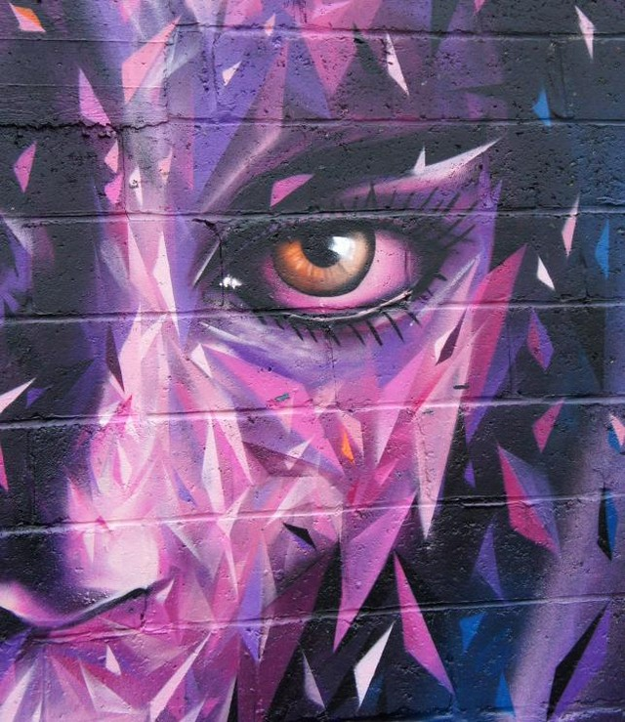

BasikBenito
benito.baero@gmail.com
@basik.benito
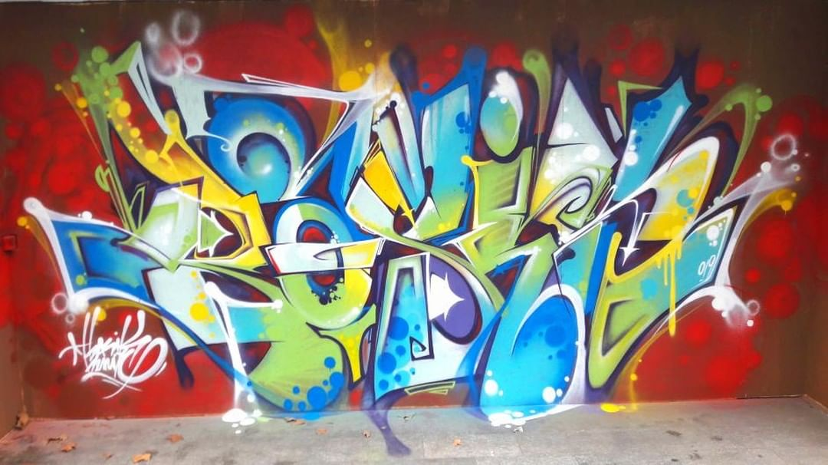

oulkadi :
djamel199@gmail.com

meskito :
meskito199@hotmail.com

exom :
89ksacrew@gmail.com
@3xomon3
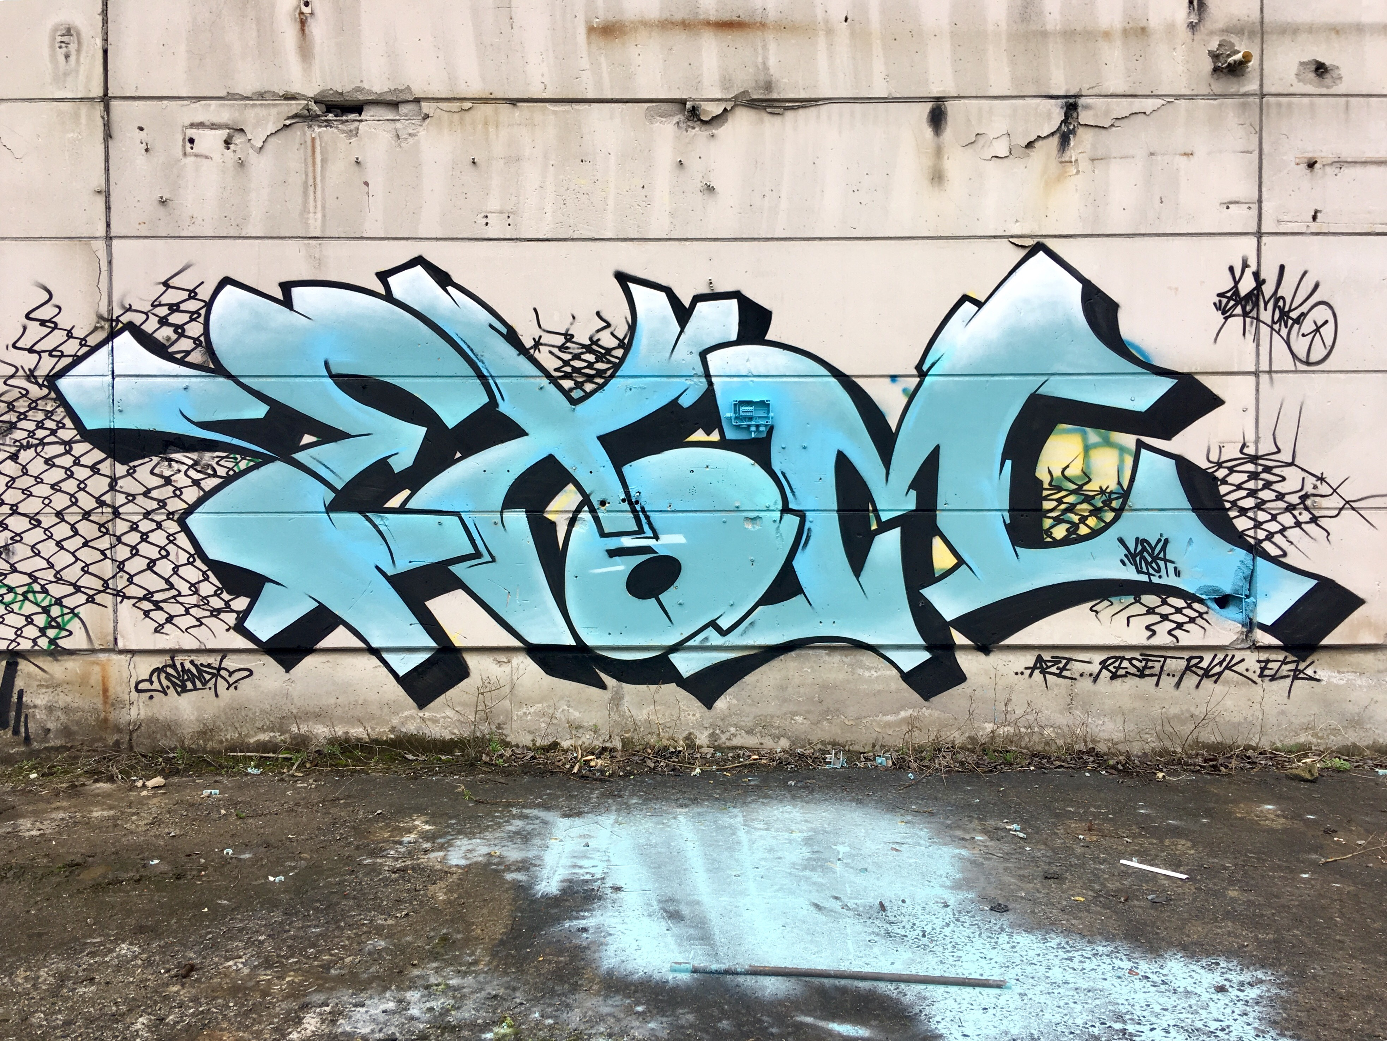

eres :
Koen_deweerdt@hotmail.com
Fb :erespaintings
@eresone
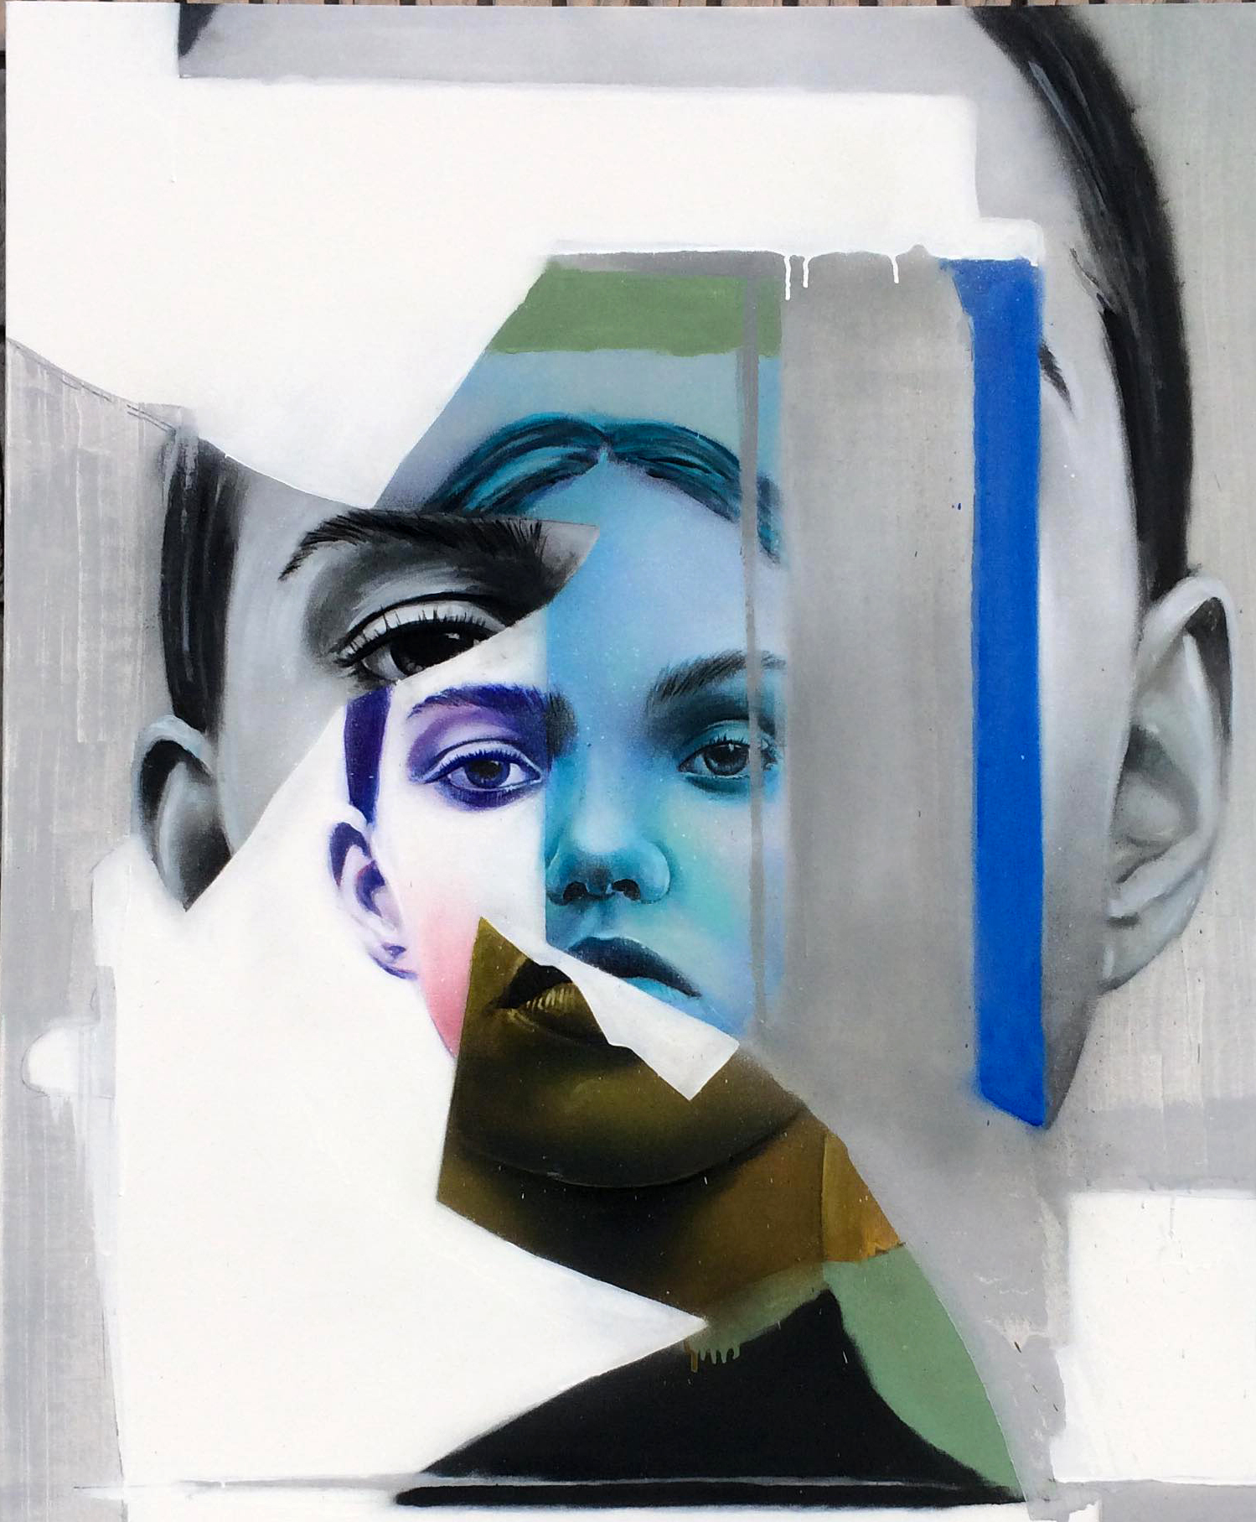Eyes be :
adrienlobet@gmail.com
http://www.eyesb.be/
https://www.instagram.com/eyes_b_tsunamigraffiti/
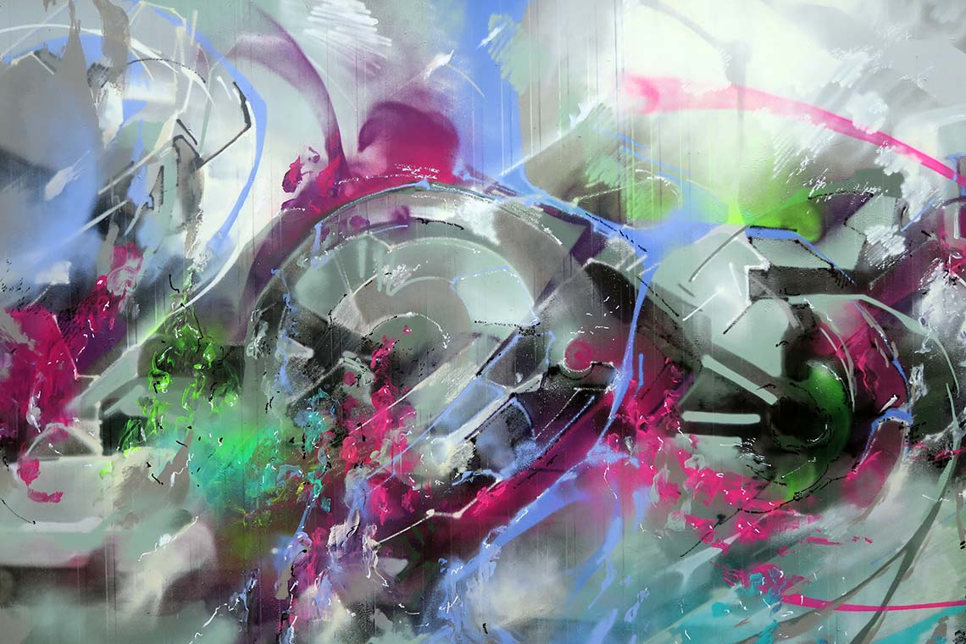

le faser :
lefasertattoo@gmail.com
@lefasertatoo
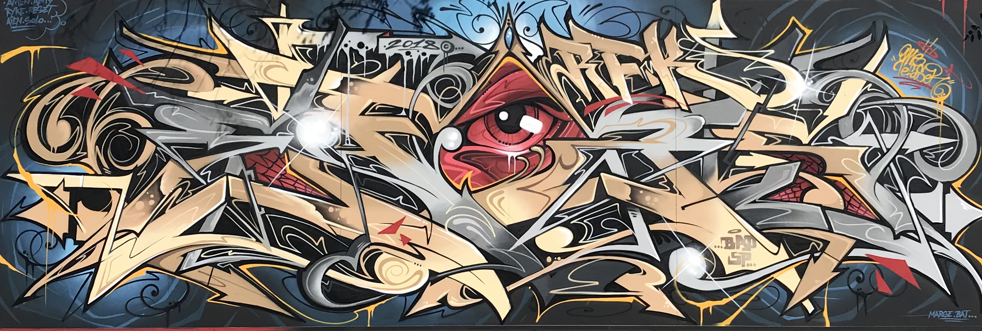

stix :
contact@stix71.net
rick wayne
Ryconer@Hotmail.com
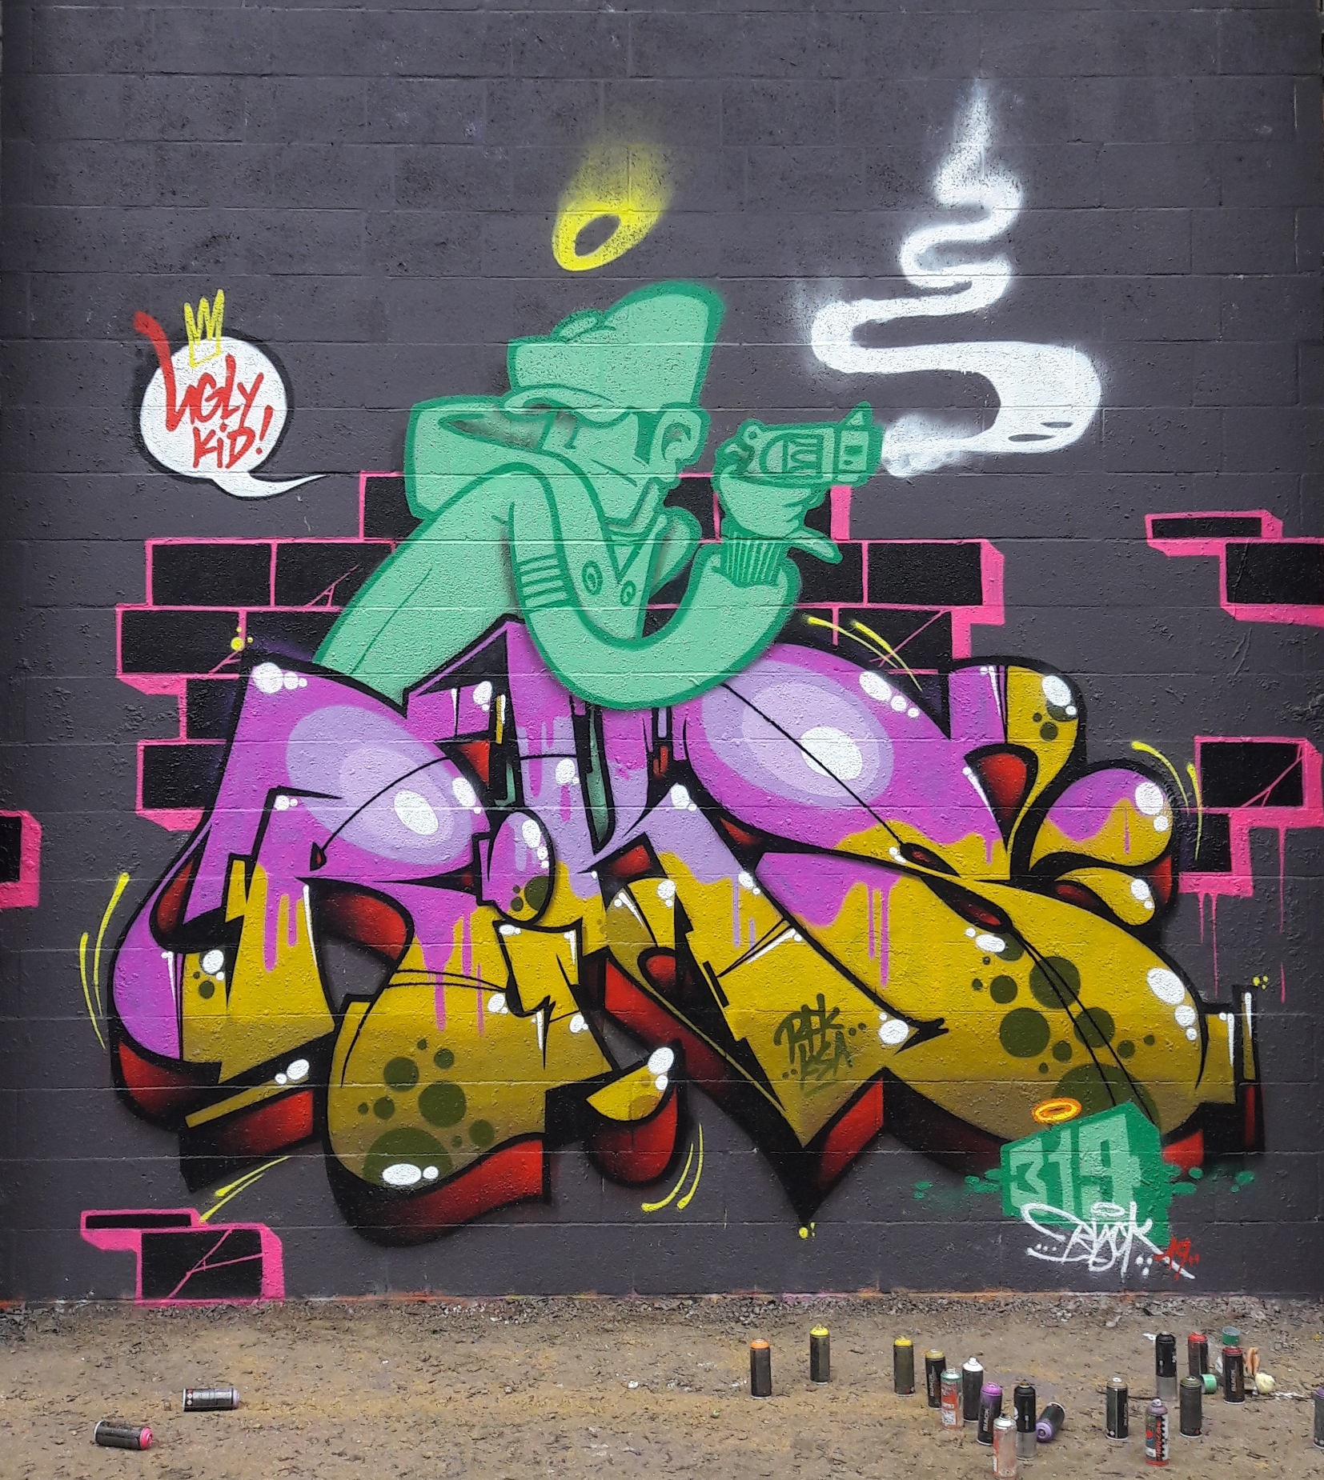

Reset
g.ree@hotmail.com
ecto
G.defeche@hotmail.be

Nean
n34n@live.fr
www.iamnean.com
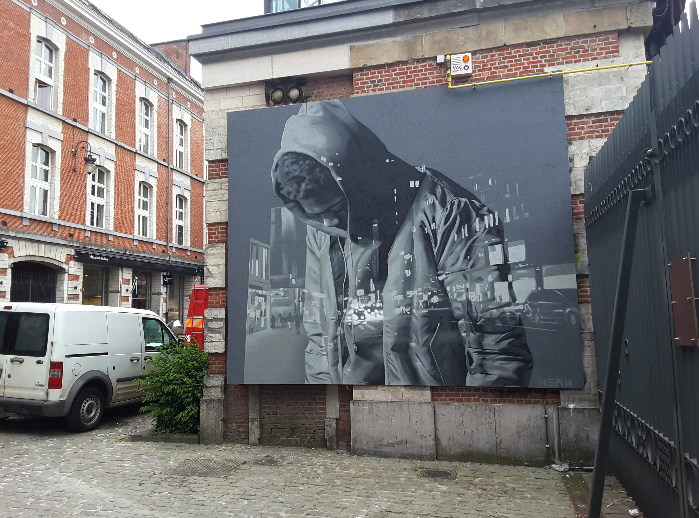

mr x :
contactxrmmrx@gmail.com
@xrmmrxgram
https://www.facebook.com/XrMMrX/

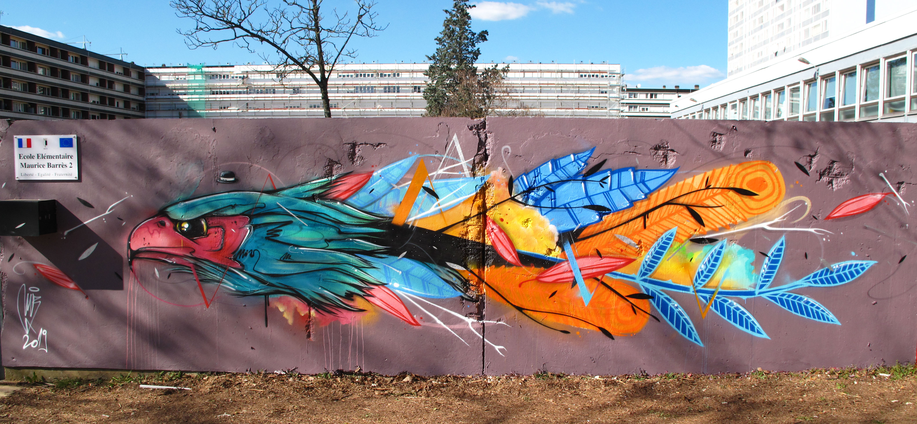

badvilx :
https://badvilx.bigcartel.com/
@badvilx
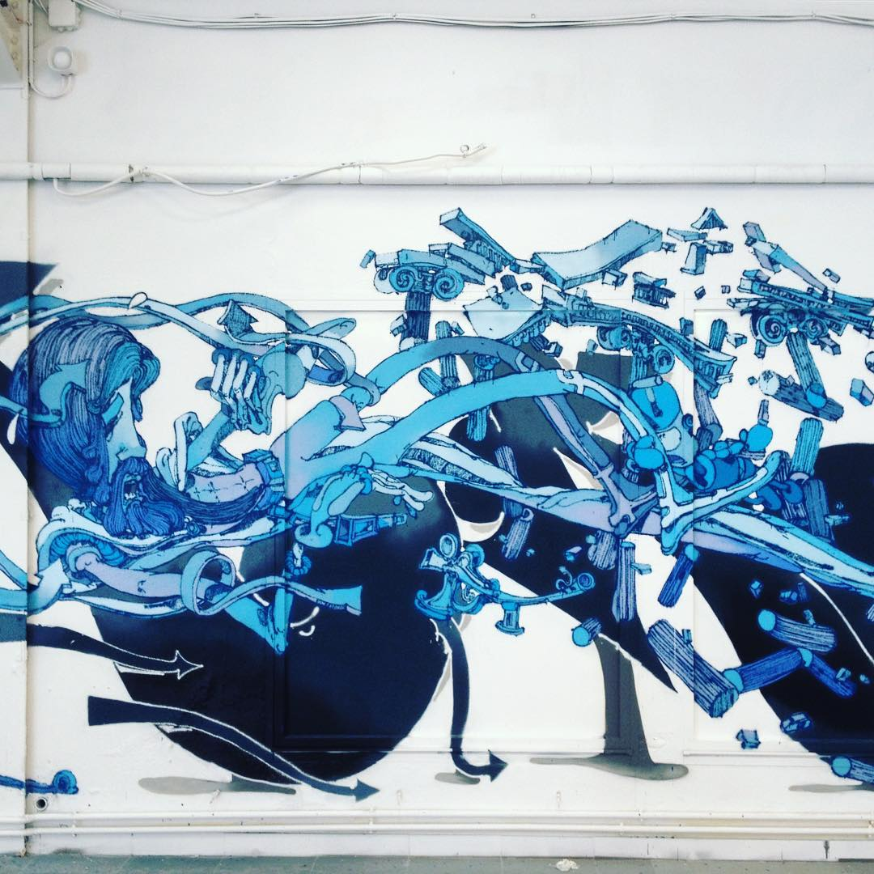

wuste :
remydannevoye@hotmail.com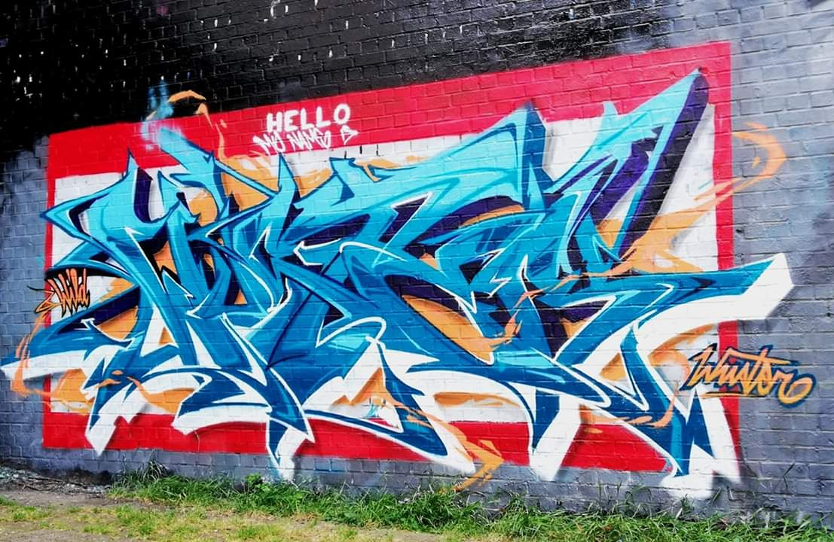
loomis
thomasringlet01@gmail.com
solo
solocink@gmail.com https://www.facebook.com/solo.cink https://www.instagram.com/solo_cink/
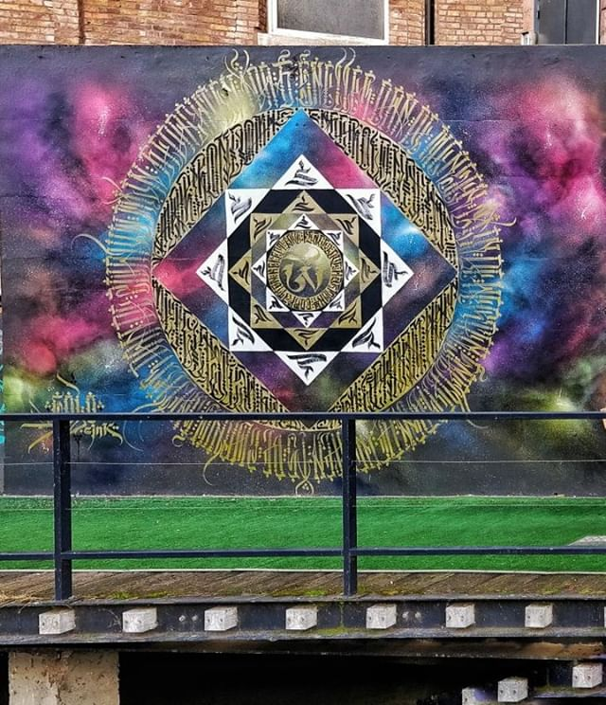

aien7
dirtyaien@gmail.com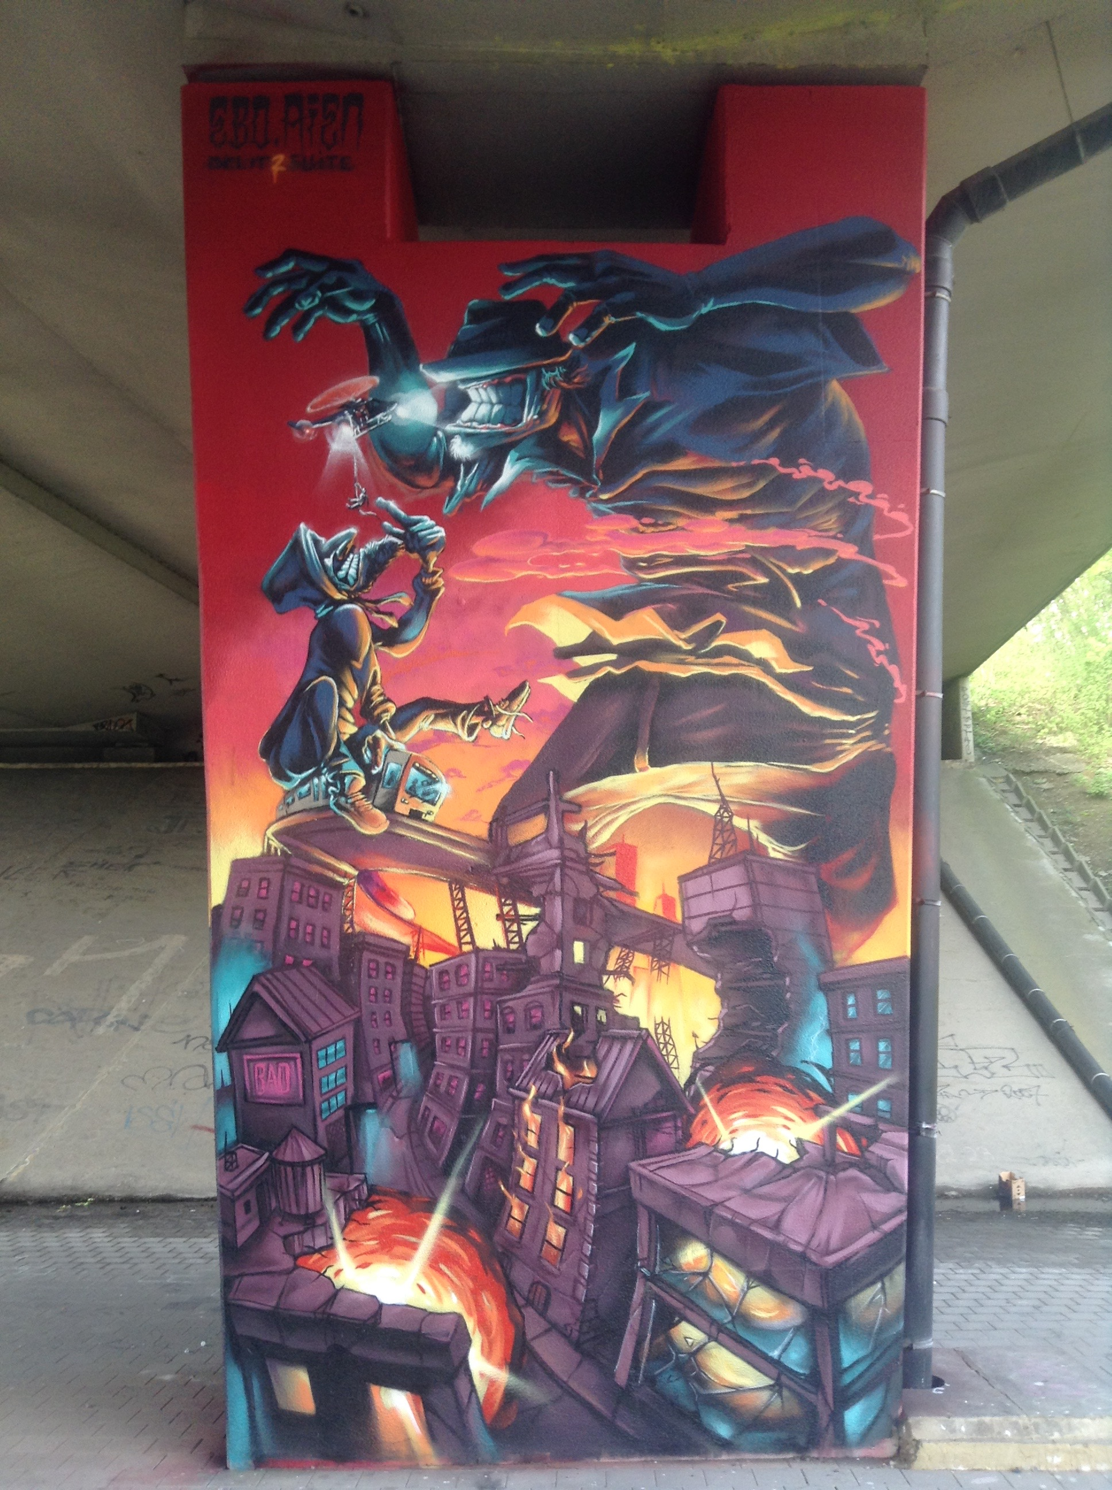

jimi
le-miich@hotmail.com

@jimmy_michaux 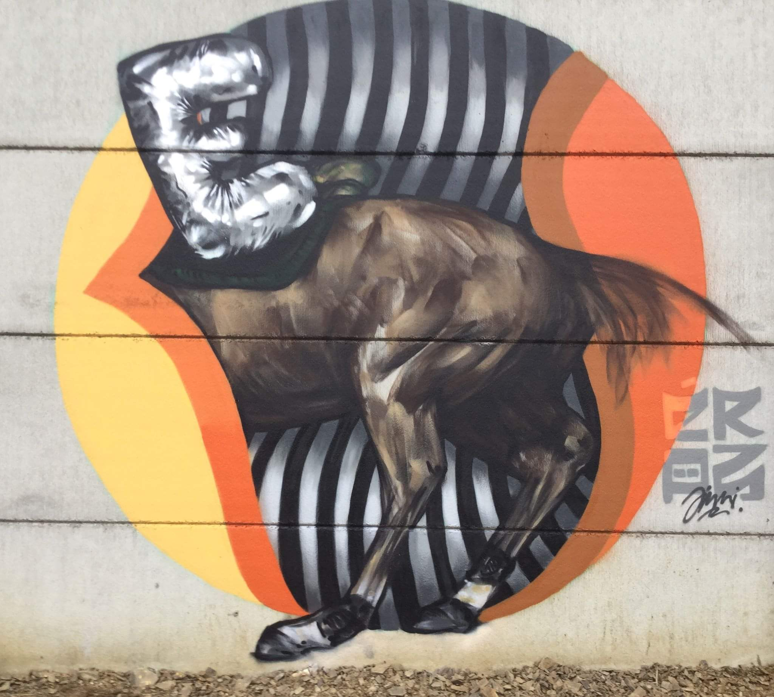
defo
fiziq84@hotmail.com
@defomanone

dake
25ideas@gmail.com
Instagram: @dakedoscinco
Facebook: @dake25 www.dake25.com
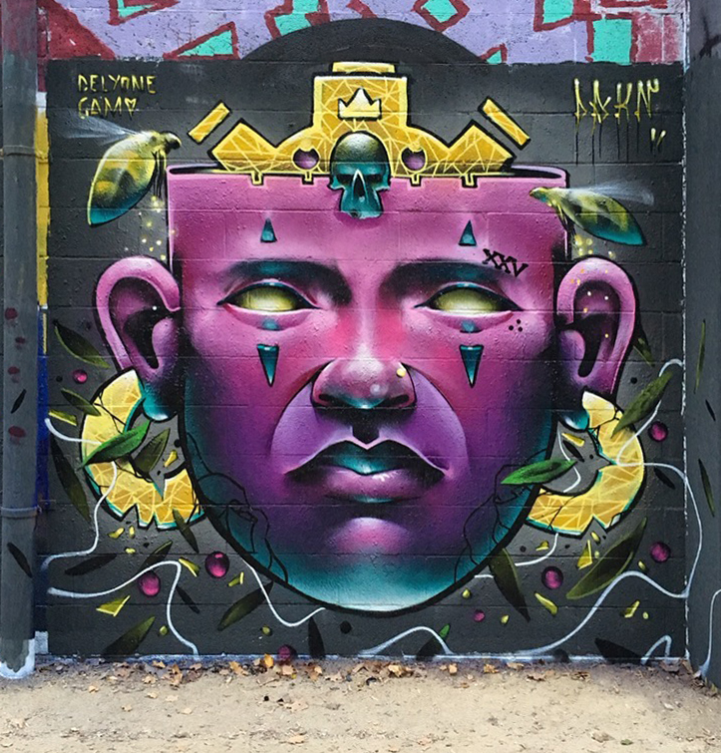
ocreos
edwin.bourquin@gmail.com
www.edwin-ocreos.com
@edwinocreos
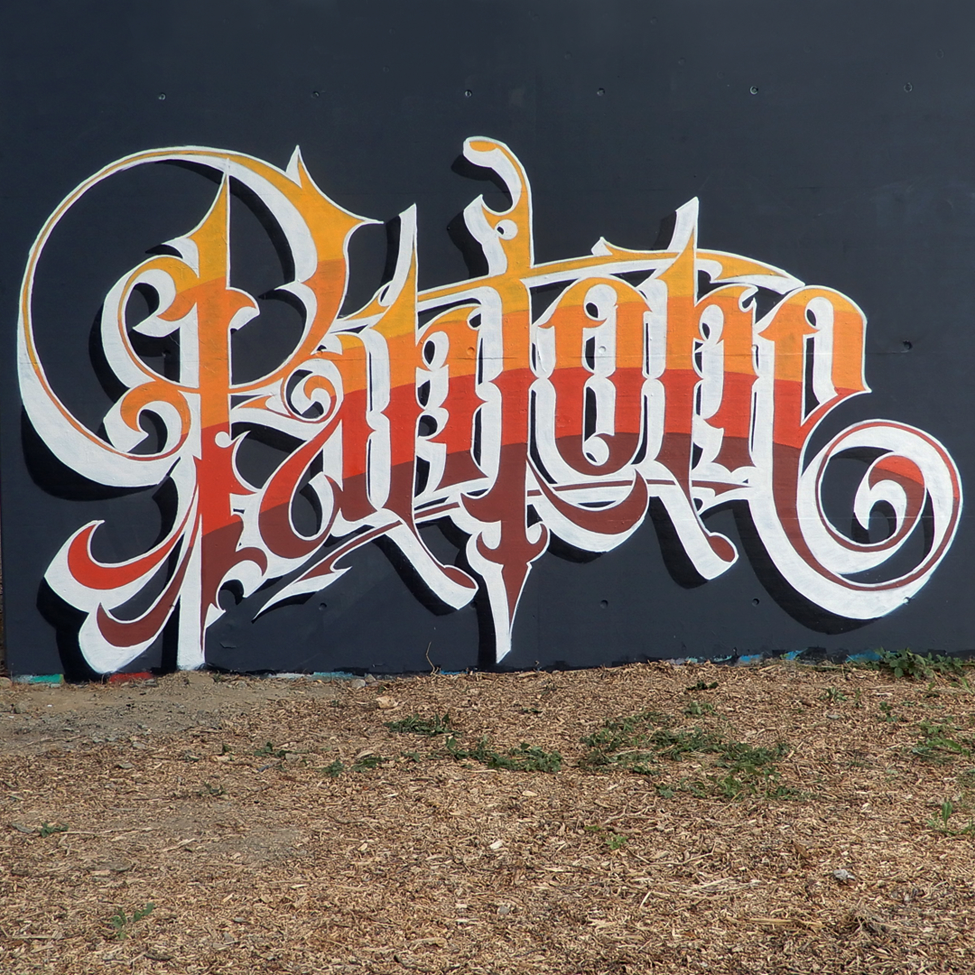
kidnapalm
max@drash.be
macgil
mohrhardtjonathan@hotmail.com
esteban
stephane_remond@hotmail.fr
mike carolo
aktarus6030@hotmail.com
